**Experiment 9 Date:** 28/03/2023

**Aim:**

Familiarization of Linux Commands

**Course Outcome(CO4):**

Write shell scripts required for system administration

**Procedure:**

1. Shell script to display date:

$vi filename.sh :- Open Editor by creating a shell script file.

Press ‘i’ to INSERT

#!/bin/bash :- To indicate the shell used

date

Press ‘Esc’ to end INSERT

:wq! :- To save and quit

chmod +x filename.sh :- To give execution permission

./filename.sh :- To execute shell script

Output:

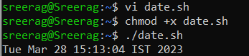

1. Shell script to display your name:

$vi filename.sh

Press ‘i’ to INSERT

#!/bin/bash

echo “What is your name?”

read name

echo “My name is $name”

Press ‘Esc’ to end INSERT

:wq!

chmod +x filename.sh

./filename.sh

Output:

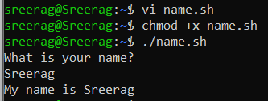

1. Multiple Commands (ls, pwd, date, mkdir) in Shell Script:

$vi filename.sh

Press ‘i’ to INSERT

#!/bin/bash

date

ls

pwd

mkdir file1

ls

Press ‘Esc’ to end INSERT

:wq!

chmod +x filename.sh

./filename.sh

Output:

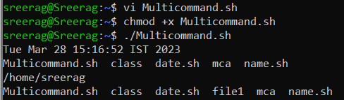

1. Shell script to demonstrate variables

$vi filename.sh

Press ‘i’ to INSERT

#!/bin/bash

echo “Enter your name: “

read name

echo “Your name is $name”

echo “File Name: $0”

echo “First Parameter: $1”

echo “Second Parameter: $2”

echo “Quoted Values: $@”

echo “Quoted Values: $*”

echo “Total Number of Parameters: $#”

Press ‘Esc’ to end INSERT

:wq!

chmod +x filename.sh

./filename.sh

Output:

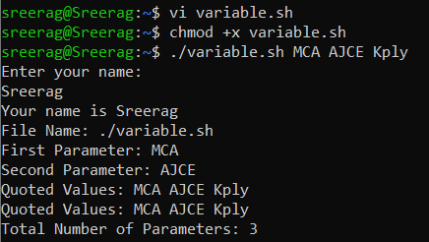

1. Shell script to count lines and words in a file

readlink -f filename :- Get path of required file

$vi filename.sh

Press ‘i’ to INSERT

#!/bin/bash

file_path = “/home/Reqfilename.sh”

countlines = `wc –lines < $file_path`

countwords = `wc –words < $file_path`

echo “Number of lines: $countlines”

echo “Number of words: $countwords”

Press ‘Esc’ to end INSERT

:wq!

chmod +x filename.sh

./filename.sh

Output:

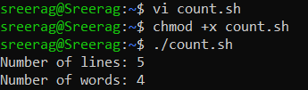

1. Shell script to display array index

$vi filename.sh

Press ‘i’ to INSERT

#!/bin/bash

Name[0] = “name1”

Name[1] = “name2”

Name[2] = “name3”

Name[3] = “name”

echo “First Index: ${Name[0]}”

echo “Second Index: ${Name[1]}”

Press ‘Esc’ to end INSERT

:wq!

chmod +x filename.sh

./filename.sh

Output:

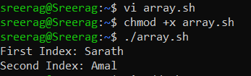

**Result:**

Output displayed successfully and CO4 was obtained.